https://www.amazon.de/enjoysolar%C2%AE-Solarpanel-12V-Solarmodul-Monokristallin/dp/B083D8GNN1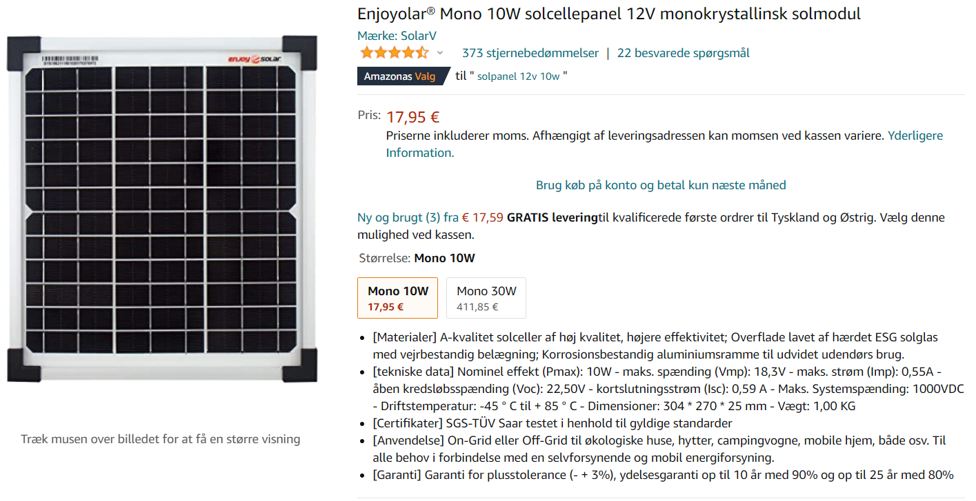 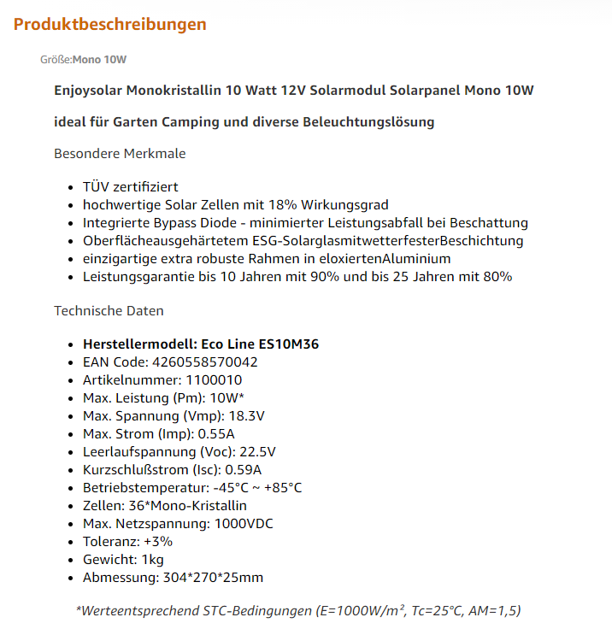
https://www.amazon.de/gp/product/B08QHLTLMV/ref=ox_sc_act_title_1?smid=A14BJ48KCUGWF5&psc=1
